LAB 01
COURSE: COMPUTER NETWORK

IPV4 ADDRESS AND NETWORK DEVICE
Name: Huỳnh Ân | ID:24560064

Objective
Part 1: Convert IPv4 Addresses from Dotted Decimal to Binary
Part 2: Use Bitwise ANDing Operation to Determine Network Addresses
Part 3: Identify IPv4 Addresses and Apply Network Address Calculations
Part 4: Classify IPv4 Addresses
Part 5: Connect the network devices
Part 6: Wireless configuration.

Submitted requirement
- Files to be submitted: Lab1.1_ID.pka, Lab1.2_ID.pka and Lab1_ID.pdf
- Name on the User profile must be changed to your ID
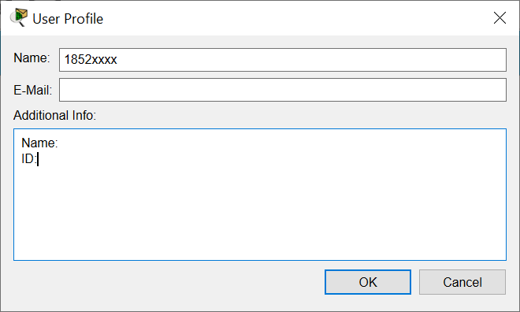
- Convert IPv4 Addresses from Dotted Decimal to Binary
  - Convert decimal numbers to their binary equivalent.
Fill in the following table by converting the decimal number to an 8-bit binary number. The first number has been completed for your reference. Recall that the eight binary bit values in an octet are based on the powers of 2, and from left to right are 128, 64, 32, 16, 8, 4, 2, and 1.
Decimal | Binary
192 | 11000000
168 | 10101000
10 | 00001010
255 | 11111111
2 | 00000010
  - Convert the IPv4 addresses to their binary equivalent.
An IPv4 address can be converted using the same technique you used above. Fill in the table below with the binary equivalent of the addresses provided. To make your answers easier to read, separate the binary octets with a period.
Decimal | Binary
192.168.10.10 | 11000000.10101000.00001010.00001010
172.16.18.183 | 10101100.00010000.00010010.10110011
10.86.252.17 | 00001010.01010110.11111100.00010001
255.255.255.128 | 11111111.11111111.11111111.10000000
255.255.192.0 | 11111111.11111111.11000000.00000000
- Use Bitwise ANDing Operation to Determine Network Addresses
In Part 2, you will use the bitwise ANDing operation to calculate the network address for the provided host addresses. You will first need to convert an IPv4 decimal address and subnet mask to their binary equivalent. Once you have the binary form of the network address, convert it to its decimal form.
Note: The ANDing process compares the binary value in each bit position of the 32-bit host IP with the corresponding position in the 32-bit subnet mask. If there two 0s or a 0 and a 1, the ANDing result is 0. If there are two 1s, the result is a 1, as shown in the example here.
  - Determine the number of bits to use to calculate the network address.
Description | Decimal | Binary
IP Address | 192.168.10.131 | 11000000.10101000.00001010.10000011
Subnet Mask | 255.255.255.192 | 11111111.11111111.11111111.11000000
Network Address | 192.168.10.128 | 11000000.10101000.00001010.10000000
In the example above, how many bits are used to calculate the network address?
_____26_________
  - Use the ANDing operation to determine the network address.
    - Enter the missing information into the table below:
Description | Decimal | Binary
IP Address | 172.16.145.29 | 10101100.00010000.10010001.00011101
Subnet Mask | 255.255.0.0 | 11111111.11111111.00000000.00000000
Network Address | 172.16.0.0 | 10101100.00010000.00000000.00000000
    - Enter the missing information into the table below:
Description | Decimal | Binary
IP Address | 192.168.10.10 | 11000000.10101000.00001010.00001010
Subnet Mask | 255.255.255.0 | 11111111.11111111.11111111.00000000
Network Address | 192.168.10.0 | 11000000.10101000.00001010.00000000
- Apply Network Address Calculations
Using command ipconfig to show the IP address of your computer and identify the IP address of your phone.
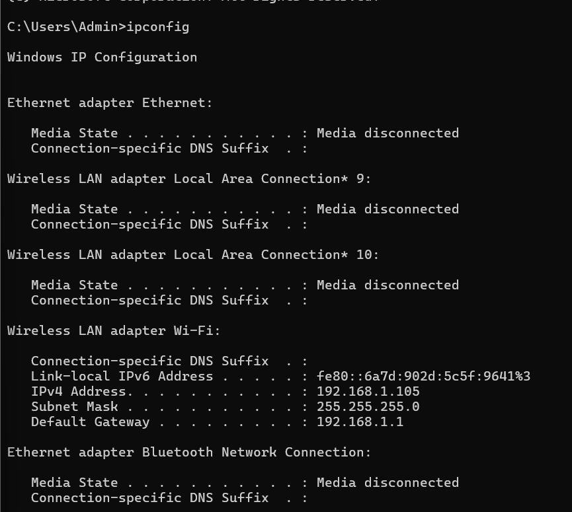

What is IP address for your PC? 192.168.1.105
What is the network address for your PC? 192.168.1.0
What is IP address for your friend’s PC/your phone? 192.168.1.103
What is the network address for your friend’s PC/your phone? 192.168.1.0
Will your PCs and your phone be able to communicate directly with each other? Yes
What is the default gateway address for your PC? 192.168.1.1
- Classify IPv4 Addresses
  - Analyze the table shown below and identify the type of address (network, host, multicast, or broadcast address).
The first row shows an example of how the table should be completed.
IP Address | Subnet Mask | Address Type
10.1.1.1 | 255.255.255.252 | host
192.168.33.63 | 255.255.255.192 | Broadcast
239.192.1.100 | 255.252.0.0 | Multicast
172.25.12.52 | 255.255.255.0 | Host
10.255.0.0 | 255.0.0.0 | Network
172.16.128.48 | 255.255.255.240 | Host
209.165.202.159 | 255.255.255.224 | Broadcast
172.16.0.255 | 255.255.0.0 | Broadcast

  - Analyze the table shown below and identify whether the address/prefix pair is a valid host address.
IP Address/Prefix | Valid Host Address? | Reason
172.16.255.0/16 | Yes | Host bits number: 16  Octet 3 and 4: 255.0 -> all not values 0 and 1
192.31.7.255/24 | No | Host bits number: 8  Octet 4: 255 -> all value 1
64.102.255.255/14 | Yes | Host bits number: 18  Octet 2, 3, and 4: 102.255.255 -> all not values 0 and 1
224.0.0.5/16 | No | Host bits number: 16  Octet 1, 2, 3, and 4 ->multicast address: Falls within the range from 224.0.0.0 to 239.255.255.255

Note: Before doing Part 5 and part 6, the students need to download and install Cisco Packet Tracer.
Students enroll the course “Packet Tracer” at and download Cisco packet tracer https://www.netacad.com/courses/packet-tracer
- Connecting network devices
Open file: Lab1.1 - Connect a Wired and Wireless LAN.pka and work with the instruction inside the simulation file.
Connecting devices: The instruction gives the table of connection type as table below; students need to choose the right cable type to connect the interfaces.
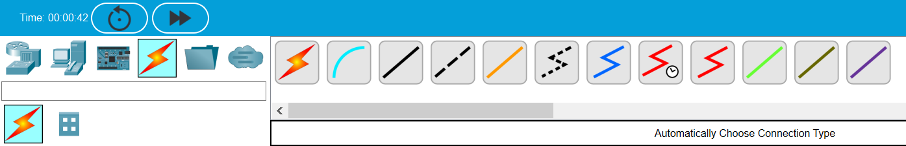

Device | Interface | Cable type | Connected device | Connects To
Cloud | Eth6 | Copper Straight-Through | Router 0 | Fa0/0
 | Coax7 | Coaxial | Cable Modem | Port0
Cable Modem | Port0 | Coaxial | Cloud | Coax7
 | Port1 | Copper Straight-Through | WirelessRouter | Internet
Router0 | Console | Console | Configuration Terminal | RS232
 | Fa0/0 | Copper Straight-Through | Cloud | Eth6
 | Fa0/1 | Copper Cross-Over | netacad.pka | Fa0
 | Ser0/0/0 | Serial | Router1 | Ser0/0
Router1 | Ser0/0 | Serial | Router0 | Ser0/0/0
 | Fa1/0 | Fiber | Switch | Fa0/1
WirelessRouter | Internet | Copper Straight-Through | Cable Modem | Port 1
 | Eth1 | Copper Straight-Through | Family PC | Fa0
After finishing the lab, students save the file with filename: Lab1.1_ID.pka
- Wireless configuration
Open file: Lab1.2 - Configure a Wireless Network.pka and work with the instruction inside the simulation file.
After finishing the lab, students save the file with filename: Lab1.2_ID.pka

